SQL DML commands

***31. Practice creating following tables***

**create table mydept_DBDA**

**(**

**deptid number primary key,**

**dname varchar2(20) not null unique,**

**dloc varchar2(20)**

**)**

**insert into mydept_DBDA values(30,'Purchase','Mumbai');**

**create table myemployee**

**(**

**empno number(5) primary key,**

**fname varchar2(15) not null,**

**mname varchar2(15),**

**lname varchar2(15) not null,**

**sal number(9,2) check(sal >=1000),**

**doj date default sysdate,**

**passportnum varchar2(15) unique,**

**deptno number constraint fk_deptno references mydept_DBDA(deptid) on delete**

**cascade**

**)**

## 

| **Column** | **Null?** | **Type** |
| --- | --- | --- |
| **DEPTID** | **NOT NULL** | **NUMBER** |
| **DNAME** | **NOT NULL** | **VARCHAR2(20)** |
| **DLOC** | **-** | **VARCHAR2(20)** |

**TABLE MYEMPLOYEE**

| **Column** | **Null?** | **Type** |
| --- | --- | --- |
| **EMPNO** | **NOT NULL** | **NUMBER(5,0)** |
| **FNAME** | **NOT NULL** | **VARCHAR2(15)** |
| **MNAME** | **-** | **VARCHAR2(15)** |
| **LNAME** | **NOT NULL** | **VARCHAR2(15)** |
| **SAL** | **-** | **NUMBER(9,2)** |
| **DOJ** | **-** | **DATE** |
| **PASSPORTNUM** | **-** | **VARCHAR2(15)** |
| **DEPTNO** | **-** | **NUMBER** |

**32. Create following tables Student, Course**

**Student (sid,sname) ---------------- sid ---primary key**

**Course(cid,cname)-------------- cid ---primary key**

**Marks(studid,courseid,marks)**

**Sample data for marks table**

**studid,courseid,marks**

**1 1 99**

**1 3 98**

**2 1 95**

**2 2 97**

create table marks(

studid number,

courseid number,

marks number,

constraint pk primary key(studid,courseid),

constraint fk_sid foreign key (studid) references student(sid) on delete cascade,

constraint fk_cid foreign key (courseid) references course(cid)

)

**TABLE STUDENT**

| **Column** | **Null?** | **Type** |
| --- | --- | --- |
| **SID** | **NOT NULL** | **NUMBER** |
| **SNAME** | **-** | **VARCHAR2(20)** |

**TABLE COURSE**

| **Column** | **Null?** | **Type** |
| --- | --- | --- |
| **CID** | **NOT NULL** | **NUMBER** |
| **CNAME** | **-** | **VARCHAR2(20)** |

**TABLE MARKS**

| **Column** | **Null?** | **Type** |
| --- | --- | --- |
| **STUDID** | **-** | **NUMBER** |
| **COURSEID** | **-** | **NUMBER** |
| **MARKS** | **-** | **NUMBER** |

## 

| **STUDID** | **COURSEID** | **MARKS** |
| --- | --- | --- |
| **1** | **3** | **98** |
| **2** | **1** | **95** |
| **2** | **2** | **97** |
| **1** | **1** | **99** |

**33. Create empty table emp10 with table structure same as emp table.**

**create table emp10 as**

**(**

**select \***

**from emp**

**where 1=2;**

**)**

**TABLE EMP10**

## 

| **Column** | **Null?** | **Type** |
| --- | --- | --- |
| **EMPNO** | **-** | **NUMBER(4,0)** |
| **ENAME** | **-** | **VARCHAR2(10)** |
| **JOB** | **-** | **VARCHAR2(9)** |
| **MGR** | **-** | **NUMBER(4,0)** |
| **HIREDATE** | **-** | **DATE** |
| **SAL** | **-** | **NUMBER(7,2)** |
| **COMM** | **-** | **NUMBER(7,2)** |
| **DEPTNO** | **-** | **NUMBER(2,0)** |

**34. Solve following using alter table**

**add primary key constraint on emp,dept,salgrade**

**emp ---- empno**

**dept--- deptno**

**salgrade--- grade**

**add foreign key constarint in emp**

**deptno --->> dept(deptno)**

**add new column in emp table netsal with constraint default 1000**

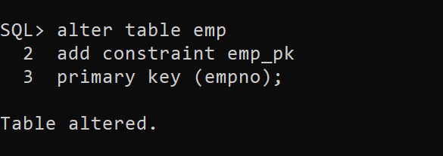

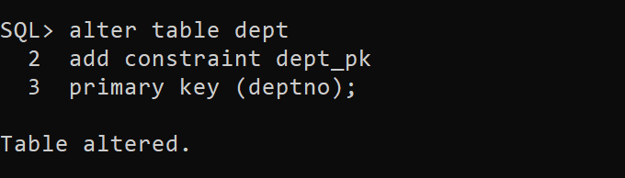

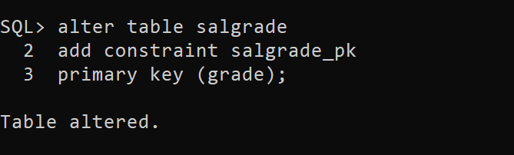

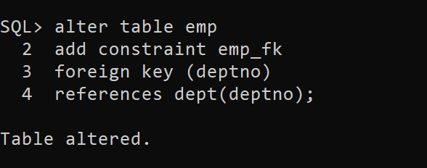

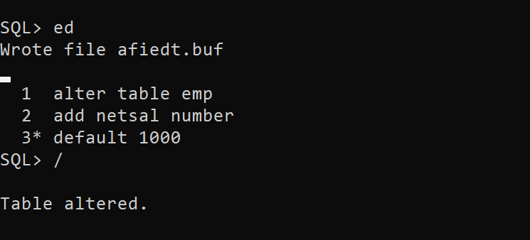

**35. Update employee sal ---- increase sal of each employee by 15 % sal +comm, change the job**

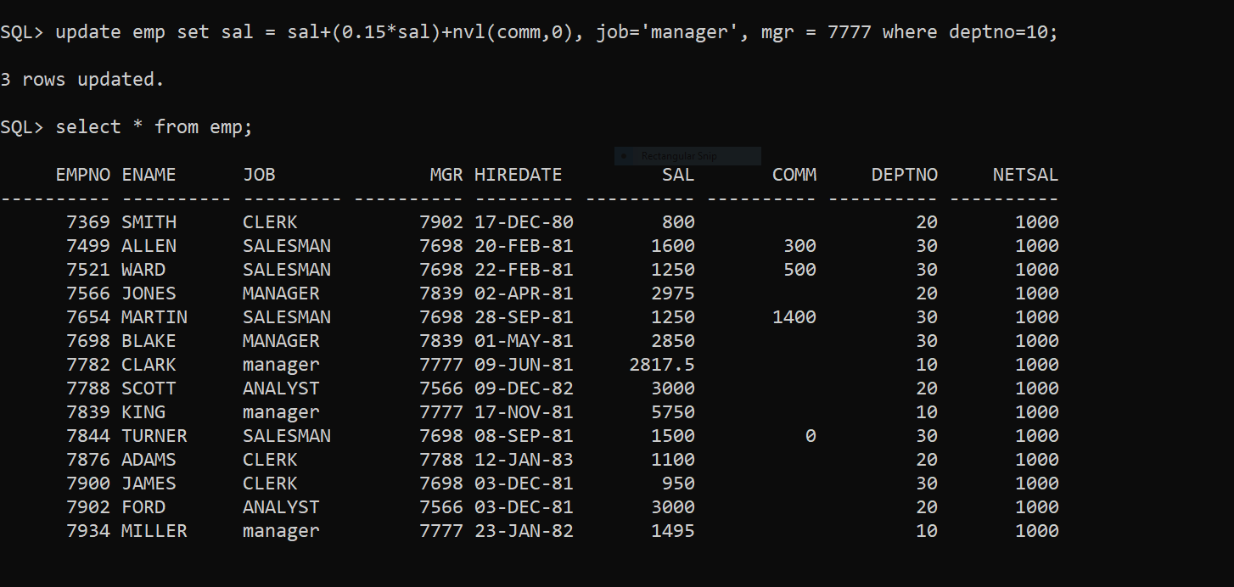

**to manager and mgr to 7777 for all employees in deptno 10.**

**36. change job of smith to senior clerk**

update emp

set job='SENIOR CLERK'

where ename='SMITH';

1 row(s) updated.

**37. increase salary of all employees by 15% if they are earning some commission**

update emp

set sal=(sal+(0.15*sal))

where comm is not null;

4 row(s) updated.

| EMPNO | ENAME | JOB | MGR | HIREDATE | SAL | COMM | DEPTNO |
| --- | --- | --- | --- | --- | --- | --- | --- |
| 7369 | SMITH | CLERK | 7902 | 17-DEC-80 | 800 | - | 20 |
| 7499 | ALLEN | SALESMAN | 7698 | 20-FEB-81 | 1840 | 300 | 30 |
| 7521 | WARD | SALESMAN | 7698 | 22-FEB-81 | 1437.5 | 500 | 30 |
| 7566 | JONES | MANAGER | 7839 | 02-APR-81 | 2975 | - | 20 |
|  |  |  |  |  |  |  |  |
| 7654 | MARTIN | SALESMAN | 7698 | 28-SEP-81 | 1437.5 | 1400 | 30 |
| 7698 | BLAKE | MANAGER | 7839 | 01-MAY-81 | 2850 | - | 30 |
| 7782 | CLARK | MANAGER | 7839 | 09-JUN-81 | 2450 | - | 10 |
| 7788 | SCOTT | ANALYST | 7566 | 09-DEC-82 | 3000 | - | 20 |
| 7839 | KING | PRESIDENT | - | 17-NOV-81 | 5000 | - | 10 |
| 7844 | TURNER | SALESMAN | 7698 | 08-SEP-81 | 1725 | 0 | 30 |
| 7876 | ADAMS | CLERK | 7788 | 12-JAN-83 | 1100 | - | 20 |
| 7900 | JAMES | CLERK | 7698 | 03-DEC-81 | 950 | - | 30 |
| 7902 | FORD | ANALYST | 7566 | 03-DEC-81 | 3000 | - | 20 |
| 7934 | MILLER | CLERK | 7782 | 23-JAN-82 | 1300 | - | 10 |

**38. list all employees with sal>smith's sal**

**select * from emp where sal> (select sal from emp where ename='SMITH');**

| **EMPNO** | **ENAME** | **JOB** | **MGR** | **HIREDATE** | **SAL** | **COMM** | **DEPTNO** |
| --- | --- | --- | --- | --- | --- | --- | --- |
| **7499** | **ALLEN** | **SALESMAN** | **7698** | **20-FEB-81** | **1840** | **300** | **30** |
| **7521** | **WARD** | **SALESMAN** | **7698** | **22-FEB-81** | **1437.5** | **500** | **30** |
| **7566** | **JONES** | **MANAGER** | **7839** | **02-APR-81** | **2975** | **-** | **20** |
| **7654** | **MARTIN** | **SALESMAN** | **7698** | **28-SEP-81** | **1437.5** | **1400** | **30** |
| **7698** | **BLAKE** | select * from emp where sal between (select sal from emp where ename=upper('rajan')) and (select sal from emp where ename=upper('revati'));  no data found  **MANAGER** | **7839** | **01-MAY-81** | **2850** | **-** | **30** |
| **7782** | **CLARK** | **MANAGER** | **7839** | **09-JUN-81** | **2450** | **-** | **10** |
| **7788** | **SCOTT** | **ANALYST** | **7566** | **09-DEC-82** | **3000** | **-** | **20** |
| **7839** | **KING** | **PRESIDENT** | **-** | **17-NOV-81** | **5000** | **-** | **10** |
| **7844** | **TURNER** | **SALESMAN** | **7698** | **08-SEP-81** | **1725** | **0** | **30** |
| **7876** | **ADAMS** | **CLERK** | **7788** | **12-JAN-83** | **1100** | **-** | **20** |
| **7900** | **JAMES** | **CLERK** | **7698** | **03-DEC-81** | **950** | **-** | **30** |
| **7902** | **FORD** | **ANALYST** | **7566** | **03-DEC-81** | **3000** | **-** | **20** |
| **7934** | **MILLER** | **CLERK** | **7782** | **23-JAN-82** | **1300** | **-** | **10** |

**39. list all employees who are working in smith's department**

**select * from emp where deptno= (select deptno from emp where ename='SMITH');**

## 

| **EMPNO** | **ENAME** | **JOB** | **MGR** | **HIREDATE** | **SAL** | **COMM** | **DEPTNO** |
| --- | --- | --- | --- | --- | --- | --- | --- |
| **7369** | **SMITH** | **CLERK** | **7902** | **17-DEC-80** | **800** | **-** | **20** |
| **7566** | **JONES** | **MANAGER** | **7839** | **02-APR-81** | **2975** | **-** | **20** |
| **7788** | **SCOTT** | **ANALYST** | **7566** | **09-DEC-82** | **3000** | **-** | **20** |
| **7876** | **ADAMS** | **CLERK** | **7788** | **12-JAN-83** | **1100** | **-** | **20** |
| **7902** | **FORD** | **ANALYST** | **7566** | **03-DEC-81** | **3000** | **-** | **20** |

**40. list all employees with sal < rajan's sal and salary > revati's sal**

SQL> select * from emp e where sal between(select sal from emp m where ename='RAJAN') and (select sal from emp P where ename='REVATI');

no rows selected

**41. delete all employees working in alan's department**

**42. change salary of Alan to the salary of Miller.**

update emp

set sal=(select sal from emp where ename='MILLER')

where ename = 'ALLEN';

1 row(s) updated.

| EMPNO | ENAME | JOB | MGR | HIREDATE | SAL | COMM | DEPTNO |
| --- | --- | --- | --- | --- | --- | --- | --- |
| 7499 | ALLEN | SALESMAN | 7698 | 20-FEB-81 | 1300 | 300 | 30 |
| 7934 | MILLER | CLERK | 7782 | 23-JAN-82 | 1300 | - | 10 |

**43. change salary of all emplees who working in Wall's department to the salary of Miller.**

update emp

set sal=(select sal from emp where ename ='MILLER')

where deptno=(select deptno from emp where ename='WALL');

0 row(s) updated.

**44. list all employees with salary > either Smith's salary or alan's sal**

select * from emp

where sal > any(select sal from emp where ename in('SMITH', 'ALAN'));

## 

| EMPNO | ENAME | JOB | MGR | HIREDATE | SAL | COMM | DEPTNO |
| --- | --- | --- | --- | --- | --- | --- | --- |
| 7839 | KING | PRESIDENT | - | 17-NOV-81 | 5000 | - | 10 |
| 7902 | FORD | ANALYST | 7566 | 03-DEC-81 | 3000 | - | 20 |
| 7788 | SCOTT | ANALYST | 7566 | 09-DEC-82 | 3000 | - | 20 |
| 7566 | JONES | MANAGER | 7839 | 02-APR-81 | 2975 | - | 20 |
| 7698 | BLAKE | MANAGER | 7839 | 01-MAY-81 | 2850 | - | 30 |
| 7782 | CLARK | MANAGER | 7839 | 09-JUN-81 | 2450 | - | 10 |
| 7844 | TURNER | SALESMAN | 7698 | 08-SEP-81 | 1725 | 0 | 30 |
| 7521 | WARD | SALESMAN | 7698 | 22-FEB-81 | 1437.5 | 500 | 30 |
| 7654 | MARTIN | SALESMAN | 7698 | 28-SEP-81 | 1437.5 | 1400 | 30 |
| 7934 | MILLER | CLERK | 7782 | 23-JAN-82 | 1300 | - | 10 |
| 7499 | ALLEN | SALESMAN | 7698 | 20-FEB-81 | 1300 | 300 | 30 |
| 7876 | ADAMS | CLERK | 7788 | 12-JAN-83 | 1100 | - | 20 |
| 7900 | JAMES | CLERK | 7698 | 03-DEC-81 | 950 | - | 30 |

**45. list all employees who earn more than average sal of dept 10**

select * from emp where sal>(select avg(sal) from emp where deptno=10);

## 

| **EMPNO** | **ENAME** | **JOB** | **MGR** | **HIREDATE** | **SAL** | **COMM** | **DEPTNO** |
| --- | --- | --- | --- | --- | --- | --- | --- |
| **7566** | **JONES** | **MANAGER** | **7839** | **02-APR-81** | **2975** | **-** | **20** |
| **7788** | **SCOTT** | **ANALYST** | **7566** | **09-DEC-82** | **3000** | **-** | **20** |
| **7839** | **KING** | **PRESIDENT** | **-** | **17-NOV-81** | **5000** | **-** | **10** |
| **7902** | **FORD** | **ANALYST** | **7566** | **03-DEC-81** | **3000** | **-** | **20** |

**46. list all employees who earn more than average sal of Alan's department**

select * from emp

where sal> (select avg(sal) from emp where deptno=(select deptno from emp where ename='ALLEN'));

## 

| EMPNO | ENAME | JOB | MGR | HIREDATE | SAL | COMM | DEPTNO |
| --- | --- | --- | --- | --- | --- | --- | --- |
| 7566 | JONES | MANAGER | 7839 | 02-APR-81 | 2975 | - | 20 |
| 7698 | BLAKE | MANAGER | 7839 | 01-MAY-81 | 2850 | - | 30 |
| 7782 | CLARK | MANAGER | 7839 | 09-JUN-81 | 2450 | - | 10 |
| 7788 | SCOTT | ANALYST | 7566 | 09-DEC-82 | 3000 | - | 20 |
| 7839 | KING | PRESIDENT | - | 17-NOV-81 | 5000 | - | 10 |
| 7844 | TURNER | SALESMAN | 7698 | 08-SEP-81 | 1725 | 0 | 30 |
| 7902 | FORD | ANALYST | 7566 | 03-DEC-81 | 3000 | - | 20 |

**47. list all employees who are working in purchase department**

select * from emp e join dept d on d.deptno=e.deptno where d.dname='Purchase';

no rows selected

**48. list all employees who earn more than average salary of their own department**

select * from emp e where sal>(select avg(sal) from emp m where m.deptno=e.deptno);

## 

| EMPNO | ENAME | JOB | MGR | HIREDATE | SAL | COMM | DEPTNO |
| --- | --- | --- | --- | --- | --- | --- | --- |
| 7566 | JONES | MANAGER | 7839 | 02-APR-81 | 2975 | - | 20 |
| 7698 | BLAKE | MANAGER | 7839 | 01-MAY-81 | 2850 | - | 30 |
| 7788 | SCOTT | ANALYST | 7566 | 09-DEC-82 | 3000 | - | 20 |
| 7839 | KING | PRESIDENT | - | 17-NOV-81 | 5000 | - | 10 |
| 7844 | TURNER | SALESMAN | 7698 | 08-SEP-81 | 1725 | 0 | 30 |
| 7902 | FORD | ANALYST | 7566 | 03-DEC-81 | 3000 | - | 20 |

**49. list all employees who earn sal < than their managers salary**

select * from emp e where e.sal<(select m.sal from emp m where m.empno=e.mgr);

## 

| EMPNO | ENAME | JOB | MGR | HIREDATE | SAL | COMM | DEPTNO |
| --- | --- | --- | --- | --- | --- | --- | --- |
| 7369 | SMITH | CLERK | 7902 | 17-DEC-80 | 800 | - | 20 |
| 7499 | ALLEN | SALESMAN | 7698 | 20-FEB-81 | 1300 | 300 | 30 |
| 7521 | WARD | SALESMAN | 7698 | 22-FEB-81 | 1437.5 | 500 | 30 |
| 7566 | JONES | MANAGER | 7839 | 02-APR-81 | 2975 | - | 20 |
| 7654 | MARTIN | SALESMAN | 7698 | 28-SEP-81 | 1437.5 | 1400 | 30 |
| 7698 | BLAKE | MANAGER | 7839 | 01-MAY-81 | 2850 | - | 30 |
| 7782 | CLARK | MANAGER | 7839 | 09-JUN-81 | 2450 | - | 10 |
| 7844 | TURNER | SALESMAN | 7698 | 08-SEP-81 | 1725 | 0 | 30 |
| 7876 | ADAMS | CLERK | 7788 | 12-JAN-83 | 1100 | - | 20 |
| 7900 | JAMES | CLERK | 7698 | 03-DEC-81 | 950 | - | 30 |
| 7934 | MILLER | CLERK | 7782 | 23-JAN-82 | 1300 | - | 10 |

**50. list all employees who are earning more than average salary of their job**

select * from emp e where e.sal>(select avg(sal) from emp m where m.deptno=e.deptno);

## 

| EMPNO | ENAME | JOB | MGR | HIREDATE | SAL | COMM | DEPTNO |
| --- | --- | --- | --- | --- | --- | --- | --- |
| 7566 | JONES | MANAGER | 7839 | 02-APR-81 | 2975 | - | 20 |
| 7698 | BLAKE | MANAGER | 7839 | 01-MAY-81 | 2850 | - | 30 |
| 7788 | SCOTT | ANALYST | 7566 | 09-DEC-82 | 3000 | - | 20 |
| 7839 | KING | PRESIDENT | - | 17-NOV-81 | 5000 | - | 10 |
| 7844 | TURNER | SALESMAN | 7698 | 08-SEP-81 | 1725 | 0 | 30 |
| 7902 | FORD | ANALYST | 7566 | 03-DEC-81 | 3000 | - | 20 |

**51. display employee name and department**

select ename, dname from emp e, dept d where d.deptno=e.deptno;

## Result Set 84

| ENAME | DNAME |
| --- | --- |
| SMITH | RESEARCH |
| ALLEN | SALES |
| WARD | SALES |
| JONES | RESEARCH |
| MARTIN | SALES |
| BLAKE | SALES |
| CLARK | ACCOUNTING |
| SCOTT | RESEARCH |
| KING | ACCOUNTING |
| TURNER | SALES |
| ADAMS | RESEARCH |
| JAMES | SALES |
| FORD | RESEARCH |
| MILLER | ACCOUNTING |

**52. display empno,name,department name and grade (use emp,dept and salgrade table)**

select e.empno, e.ename, d.dname, s.grade from emp e, dept d, salgrade s

where e.deptno = d.deptno and e.sal between s.losal and s.hisal;

## 

| EMPNO | ENAME | DNAME | GRADE |
| --- | --- | --- | --- |
| 7934 | MILLER | ACCOUNTING | 2 |
| 7782 | CLARK | ACCOUNTING | 4 |
| 7839 | KING | ACCOUNTING | 5 |
| 7369 | SMITH | RESEARCH | 1 |
| 7876 | ADAMS | RESEARCH | 1 |
| 7566 | JONES | RESEARCH | 4 |
| 7788 | SCOTT | RESEARCH | 4 |
| 7902 | FORD | RESEARCH | 4 |
| 7900 | JAMES | SALES | 1 |
| 7499 | ALLEN | SALES | 2 |
| 7521 | WARD | SALES | 3 |
| 7654 | MARTIN | SALES | 3 |
| 7844 | TURNER | SALES | 3 |
| 7698 | BLAKE | SALES | 4 |

**53. list all employees number,name, mgrno and manager name**

select e.ename, e.empno, (select m.ename from emp m where e.mgr=m.empno) "Manager Name" from emp e;

OR

select e.ename,e.empno, e.mgr, m.ename “Manager Name” from emp e, emp m

where e.mgr=m.empno;

| **ENAME** | **EMPNO** | **MGR** | **Manager Name** |
| --- | --- | --- | --- |
| **SMITH** | **7369** | **7902** | **FORD** |
| **ALLEN** | **7499** | **7698** | **BLAKE** |
| **WARD** | **7521** | **7698** | **BLAKE** |
| **JONES** | **7566** | **7839** | **KING** |
| **MARTIN** | **7654** | **7698** | **BLAKE** |
| **BLAKE** | **7698** | **7839** | **KING** |
| **CLARK** | **7782** | **7839** | **KING** |
| **SCOTT** | **7788** | **7566** | **JONES** |
| **KING** | **7839** | **-** | **-** |
| **TURNER** | **7844** | **7698** | **BLAKE** |
| **ADAMS** | **7876** | **7788** | **SCOTT** |
| **JAMES** | **7900** | **7698** | **BLAKE** |
| **FORD** | **7902** | **7566** | **JONES** |
| **MILLER** | **7934** | **7782** | **CLARK** |

**54. create following tables and solve following questions(primary keys are marked in yellow)**

**foreign keys are marked in green**

**product(pid,pname,price,qty,cid,sid)**

create table product(

pid number,

pname varchar2(20),

price number,

qty number,

cid number,

sid number

);

**salesman (sid,sname,address)**

create table salesman(

sid number,

sname varchar2(20),

address varchar2(50)

);

**category(cid,cnam,description)**

create table category(

cid number,

cname varchar2(20),

description varchar2(50)

);

alter table salesman

add constraint pk_salesman primary key (sid);

alter table category

add constraint pk_category primary key(cid);

alter table product

add constraint pk_product primary key (pid);

add constraint fk_cid1 foreign key (cid) references on category(cid);

add constraint fk_sid1 foreign key (sid) references on salesman(sid);

insert all

into salesman(sid,sname,address) values(1,'shivam','PUNE')

into salesman(sid,sname,address) values(2,'aditya','AMBAJOGAI')

into salesman(sid,sname,address) values(3,'shreyas','NAGAR')

into salesman(sid,sname,address) values(4,'soham','NAGPUR')

into salesman(sid,sname,address) values(5,'atharva','SATARA')

into salesman(sid,sname,address) values(6,'ajinkya','NAGAR')

into category(cid,cname,description) values(11,'BOTTLE','LENSCART')

into category(cid,cname,description) values(12,'LAPTOP','APPLE')

into category(cid,cname,description) values(13,'BOOKS','PRAGATI')

into category(cid,cname,description) values(14,'PEN','CELLO')

into product(pid,pname,price,qty,sid,cid) values(101,'hp',50000,50,1,12)

into product(pid,pname,price,qty,sid,cid) values(102,'dell',49450,20,5,12)

into product(pid,pname,price,qty,sid,cid) values(103,'asus',25648,90,6,12)

into product(pid,pname,price,qty,sid,cid) values(104,'ACER',36589,60,2,12)

into product(pid,pname,price,qty,sid,cid) values(105,'history',540,500,3,13)

into product(pid,pname,price,qty,sid,cid) values(106,'everyone',519,250,5,13)

into product(pid,pname,price,qty,sid,cid) values(107,'bigdate',220,90,4,13)

into product(pid,pname,price,qty,sid,cid) values(108,'CELLO',5,50,1,14)

into product(pid,pname,price,qty,sid,cid) values(109,'Montex',50,50,2,14)

into product(pid,pname,price,qty,sid,cid) values(110,'STEEL',200,50,1,11)

into product(pid,pname,price,qty,sid,cid) values(111,'GLASS',239,50,1,11)

select * from dual

/

**1. list all product name,their category name and name of a person, who sold that product**

select pid,pname,c.cid,c.cname,s.sname from product p, salesman s,category c where p.sid=s.sid and p.cid=c.cid;

PID PNAME CID CNAME SNAME

---------- ---------- ---------- ---------- ----------

108 CELLO 14 PEN shivam

101 hp 12 LAPTOP shivam

111 GLASS 11 BOTTLE shivam

110 STEEL 11 BOTTLE shivam

109 Montex 14 PEN aditya

104 ACER 12 LAPTOP aditya

105 history 13 BOOKS shreyas

107 bigdate 13 BOOKS soham

106 everyone 13 BOOKS atharva

102 dell 12 LAPTOP atharva

103 asus 12 LAPTOP ajinkya

**2. list all product name and salesman name for all salesman who stays in pune**

select pid,pname,s.sname from product p, salesman s where p.sid=s.sid and s.address='PUNE';

PID PNAME SNAME

---------- ---------- ----------

101 hp shivam

110 STEEL shivam

111 GLASS shivam

108 CELLO shivam

**3. list all product name and category name**

select pname,c.cname from product p full join category c on p.cid=c.cid ;

PNAME CNAME

---------- ----------

hp LAPTOP

dell LAPTOP

asus LAPTOP

ACER LAPTOP

history BOOKS

everyone BOOKS

bigdate BOOKS

CELLO PEN

Montex PEN

STEEL BOTTLE

GLASS BOTTLE

**55. create following tables and solve following questions(primary keys are marked in yellow)**

**foreign keys are marked in green**

**faculty(fid,fname,sp.skill1,sp.skill2)**

create table faculty(

fid number,

fname varchar2(20),

sp_skill1 varchar2(20),

sp_skill2 varchar2(20)

);

**courses(cid,cname,rid,fid)**

create table courses(

cid number,

cname varchar2(20),

rid number,

fid number

);

**room(roomid,rname,rloc)**

create table room(

roomid number,

rname varchar2(20),

rloc varchar2(20)

);

**faculty**

**fid fname spskill1 spskill2**

**10 kjzhcjhz a b**

**11 sdd x z**

**12 lksjk a x**

**13 ksdjlkj a b**

insert into faculty values(10, 'kjzhcjhz', 'a', 'b');

insert into faculty values(11, 'sdd', 'x', 'y');

insert into faculty values(12, 'lksjk', 'a', 'x');

insert into faculty values(13, 'ksdjlkj', 'a', 'b');

alter table faculty

add constraint pk_faculty primary key(fid);

alter table room

add constraint pk_room primary key(roomid);

alter table courses

add constraint pk_courses primary key(cid);

add constraint fk_courses1 foreign key(rid) references room(roomid);

add constraint fk_courses2 foreign key(fid) references faculty(fid);

**courses**

**cid cname rid fid**

**121 DBDA 100 10**

**131 DAC 101**

**141 DTISS**

**151 DIOT 105 12**

insert into courses values(121, 'DBDA', '100', '10');

insert into courses (cid, cname, rid)values(131, 'DAC', '101');

insert into courses (cid, cname)values(141, 'DTISS');

insert into courses values(151, 'DIOT', '105', '12');

**Room**

**roomid rname rloc**

**100 jasmin 1st floor**

**101 Rose 2nd floor**

**105 Lotus 1st floor**

**103 Mogra 1st floor**

insert all

into faculty(fid,fname, spskill1, spskill2) values(10, 'rohit', 'a','b')

into faculty(fid,fname, spskill1, spskill2) values(11, 'shantanu', 'x','z')

into faculty(fid,fname, spskill1, spskill2) values(12, 'pretty', 'a','x')

into faculty(fid,fname, spskill1, spskill2) values(13, 'pryanka', 'a','b')

insert into room values(100, 'jasmin', '1st floor');

insert into room values(101, 'Rose', '2nd floor');

insert into room values(105, 'Lotus', '1st floor');

insert into room values(103, 'Mogra', '1st floor');

**1. list all courses for which no room is assigned and all rooms for which are**

**Available**

select cid,c.rname as cname,r.roomid from courses c full join room r on c.rid=r.roomid where cid is null or roomid is null;

CID CNAME ROOMID

---------- -------------------- ----------

103

141 DITISS

**2. list all faculties who are not allocated to any course and rooms which are not**

**allocated to any course**

select f.fname,c.rname as cname,r.rname from courses c full join room r on c.rid=r.roomid full join faculty f on c.fid=f.fid where fname is null or c.rname is null or r.rname is null;

FNAME CNAME RNAME

-------------------- -------------------- --------------------

shantanu

pryanka

DITISS

Morga

DAC Rose

**3. list all rooms which are allocated or not allocated to any courses**

select cid,c.rname as cname,r.roomid,r.rname from courses c right join room r on c.rid=r.roomid;

CID CNAME ROOMID RNAME

---------- -------------------- ---------- --------------------

121 DBDA 100 jasmin

131 DAC 101 Rose

151 DIOT 105 Lotus

103 Morga

**4. list all rooms which are not allocated to any courses**

select roomid,r.rname from room r where not exists(select cid from courses c where c.rid=r.roomid);

ROOMID RNAME

---------- --------------------

103 Morga

select r.roomid,r.rname,cid,c.rname as cname from courses c right join room r on c.rid=r.roomid where c.rid is null;

ROOMID RNAME CID CNAME

---------- -------------------- ---------- --------------------

103 Morga

**5. display courses and faculty assigned to those courses whose special skill is**

**Database**

select cid,c.rname as cname,f.fid,f.fname from courses c join faculty f on c.fid=f.fid where spskill1='a';

CID CNAME FID FNAME

---------- -------------------- ---------- --------------------

121 DBDA 10 rohit

151 DIOT 12 pretty

**6. display time table --- it should contain course details , faculty and room**

**details**

select cid,c.rname,fname,r.rname from courses c join room r on c.rid=r.roomid join faculty f on c.fid=f.fid;

CID RNAME FNAME RNAME

---------- -------------------- -------------------- --------------------

121 DBDA rohit jasmin

151 DIOT pretty Lotus

**56. create following tables with given constraints**

**product---- qty >0, default 20.00,pname not null and unique**

**prodid pname qty price catid sid**

**123 lays 30 30.00 1 12**

**111 pepsi 40 50.00 4 11**

**134 nachos 50 50.00 1 12**

**124 dairy milk 40 60.00 2 14**

**124 pringles 40 60.00 1 14**

create table product(

prodid number,

pname varchar2(50) unique not null,

qty number check(qty>0),

price number default 20.00,

catid number,

sid number

);

insert into product values(123, 'lays', 30, 30.00, 1, 12);

insert into product values(111, 'pepsi', 40, 50.00, 4, 11);

insert into product values(134, 'nachos', 50, 50.00, 1, 12);

insert into product values(124 ,'dairy milk', 40, 60.00, 2, 14);

insert into product values(124, 'pringles', 40, 60.00, 1, 14);

**saleman ----- sname -----not null**

**sid sname city**

**11 Rahul Pune**

**12 Kirti Mumbai**

**13 Prasad Nashik**

**14 Arnav Amaravati**

create table salesman(

sid number,

sname varchar2(20) not null,

city varchar2(20)

);

insert into salesman values(11, 'Rahul' ,'Pune');

insert into salesman values(12, 'Kirti' ,'Mumbai');

insert into salesman values(13, 'Prasad' ,'Nashik');

insert into salesman values(14, 'Arnav' ,'Amaravati');

**category ---- cname unique and not null**

**cid cname description**

**1 chips very crunchy**

**2 chocolate very chocolaty**

**3 snacks yummy**

**4 cold drinks thanda thanda cool cool**

create table category(

cid number,

cname varchar2(20) not null unique,

description varchar2(20)

);

insert into category values(1, 'chips', 'very crunchy');

insert into category values(2, 'chocolate ', 'very chocolaty');

insert into category values(3, 'snacks ', 'yummy');

insert into category values(4, 'cold drinks', 'thanda thanda cool cool');

**1. List all products with category chips**

**select prodid, pname, qty, price, cname from product p, category c**

**where p.catid=c.cid and cname='chips';**

## 

| **PRODID** | **PNAME** | **QTY** | **PRICE** | **CNAME** |
| --- | --- | --- | --- | --- |
| **123** | **lays** | **30** | **30** | **chips** |
| **134** | **nachos** | **50** | **50** | **chips** |
| **124** | **pringles** | **40** | **60** | **chips** |

**2. display all products sold by kirti**

select prodid, pname,sname from product p, salesman s

where p.sid=s.sid and s.sname='Kirti';

## 

| PRODID | PNAME | SNAME |
| --- | --- | --- |
| 123 | lays | Kirti |
| 134 | nachos | Kirti |

**3. display all salesman who do not sold any product**

select * from salesman s

where not exists(select * from product p where p.sid=s.sid );

## 

| SID | SNAME | CITY |
| --- | --- | --- |
| 13 | Prasad | Nashik |

**4. display all category for which no product is there**

select * from category c where not exists(select* from product p where p.catid=c.cid);

## 

| CID | CNAME | DESCRIPTION |
| --- | --- | --- |
| 3 | snacks | yummy |

**5. display all products with no category assigned**

select * from product p where not exists(select* from category c where p.catid=c.cid);

## 

| PRODID | PNAME | QTY | PRICE | CATID | SID |
| --- | --- | --- | --- | --- | --- |
| 111 | pepsi | 40 | 50 | 4 | 11 |

**6. list all salesman who stays in city with name starts with P or N**

select * from salesman where city like 'P%' or city like 'N%';

## 

| SID | SNAME | CITY |
| --- | --- | --- |
| 11 | Rahul | Pune |
| 13 | Prasad | Nashik |

**7. add new column in salesman table by name credit limit**

ALTER TABLE salesman

add credit_limit number;

**TABLE SALESMAN**

| **Column** | **Null?** | **Type** |
| --- | --- | --- |
| **SID** | **-** | **NUMBER** |
| **SNAME** | **NOT NULL** | **VARCHAR2(20)** |
| **CITY** | **-** | **VARCHAR2(20)** |
| **CREDIT_LIMIT** | **-** | **NUMBER** |